**Principles of Microeconomics**

**Group Project**

**Semester 1, 2020**

## Name: 邝安东 覃龙 杨宗瑜 王珣玮

**Class: Business Administration Class 2**

**Date of Submission: December 30, 2020**

1. **Introduction**

With the increasingly serious environmental pollution, the impact of greenhouse effect is expanding. In order to achieve energy saving and emission reduction, new energy vehicles have developed rapidly. As an emerging industry, it has a lot in common with the traditional automobile industry, but there are also many different aspects.Because of its green characteristics, its development is strongly supported by the relevant government departments.But compared with traditional cars, it has some problems, such as inconvenient charging and so on,so consumers will consider more when they want to buy a new energy vehicle. At the same time, there are many competitors represented by Tesla and BYD in the market of new energy vehicles.In the following, we will analyze some aspects of this industry, including **Demand＆Supply, Elastic, Government action, Consumer preference,Producer behavior.**We hope that through these analyses, we can have a better understanding of this industry and predict its future development trend.

## Discussion

**Newspaper Article #1**

Article Title: China's new energy vehicles "win" the market in 2020 and next year is more likely

Article URL: http://www.xinhuanet.com/auto/2020-12/23/c_1126897191.htm

Microeconomics concept discussed: Demand & Supply

*Overview:*

*Though coming across the COVID-19 epidemic, new energy vehicle market of China has kept a robust growth in 2020. According to SAE-China’s prediction, throughout 2020, there will be 130,000,000 new energy vehicles sold in China, which is 8% more than last year’s sales volume. To explain this phenomenon, I draw a graph to describe the demand and supply change of the new energy vehicle market. Meanwhile, I will explain the changes from these two major aspects.*

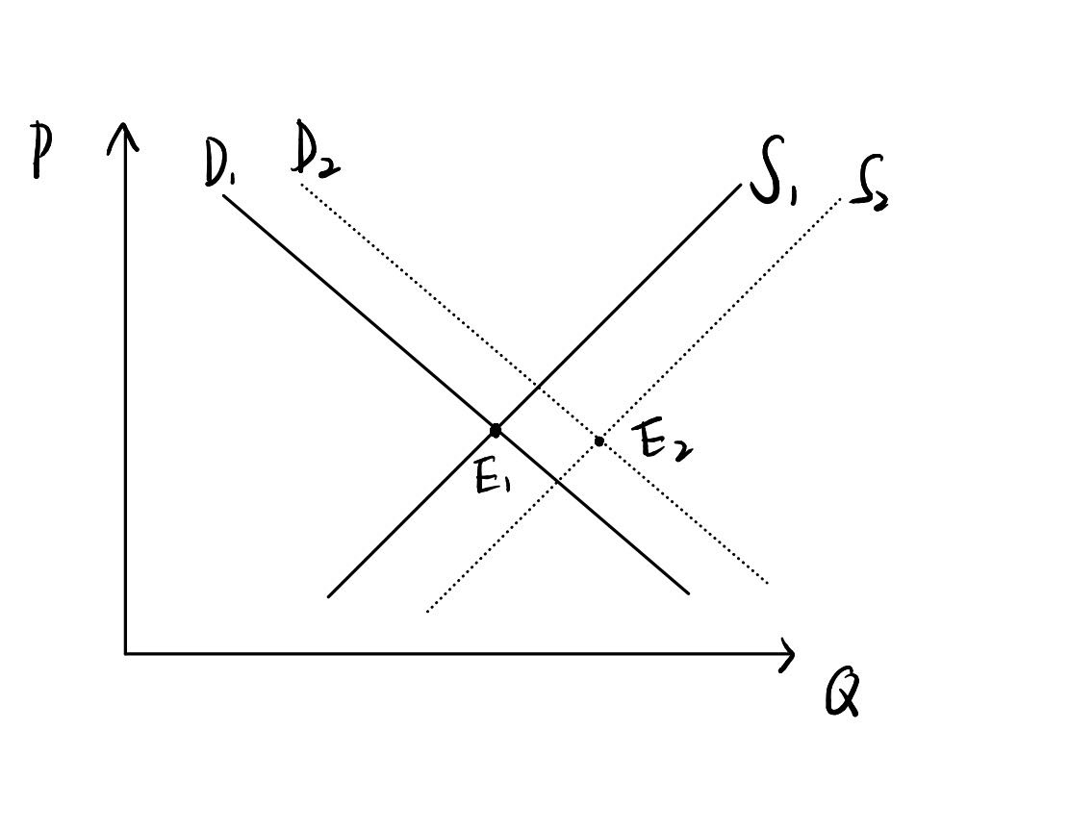

*Demand & Supply Change of the New Energy Vehicle Market*

*Reasons for the demand curve change:*

1. *The quantity of buyers: The quantity of buyers increases this year. The government make an effort to spur the NEV selling in the countryside market, bringing a growth to the buyer quantity. More than that, personal customers are more than the past year.*
2. *The preference of buyers: The NEV suppliers keep pace with the development of technology and pay much attention to develop the NEV cars’ appearance, user experience, quality etc. Due to this reason NEV cars cater better to young customers. What’s more, with the new-published national standards of NEV cars put into use this year, people have a better trust on the NEV cars.*
3. *Expectation: The bonus policy is prolonged by the government, the prices of NEV cars are expected to be steady or lower. And by the end of 2020, the epidemic has been controlled in China, people’s expectation to income and economy is better.*
4. *Relevant goods: The government pays more effort to construct* *infrastructure for NEV cars. The cost to charge is lower because of the construction of charging piles, natural gas station etc.*
5. *Price: The prices are relatively steady.*

*Reasons for the supply curve change:*

1. *Technology: The technology of NEV producing is improving year by year, by accumulating producing technology and experience, NEV suppliers is lowering down the producing cost.*
2. *The quantities of suppliers: Not only there are companies like Tesla producing NEV cars, traditional car producers like Audi, BMW, Benz also enter this promising field to produce their own NEV cars. Thus, the quantities of suppliers are larger.*
3. *Expectation: The government is publishing friendly policies to spur the development NEV technology. There are financial subsidies for the producers, tax reduction for buyers, government bonus for R&D, infrastructure construction, leading development plan on country level etc., thus the expectation of NEV field optimistic.*
4. *Price: The prices are relatively steady.*
5. *Inputs’ prices: The rapid growth and rising production capacity of power battery and electromotor companies has brought lower-priced raw materials to NEV car makers.*

*Conclusion:*

*The change of sales volume of new energy vehicles is the result of the change of supply and demand, which will be conducive to the healthy development of new energy vehicles industry and the transformation of China to green development.*

## Newspaper Article #2

### Article Title: 卖最好的不是特斯拉 9月新能源汽车销量TOP5（The best seller was not Tesla's TOP5 new energy vehicle sales in September）

Article URL: https://www.chexiaoliang.com/nengyuan/1817.html

Microeconomics concept discussed: elasticity

This article shows the sales volume and guiding prices of the five best-selling new energy vehicles in September. It can be intuitively seen that the price and demand of new energy vehicles are not highly elastic. The Tesla model3 with an average price of more than 300,000 yuan does not show a low sales performance due to its high price. Meanwhile, Hongguang MINI EV and Chery eQ1, both priced within 100,000 yuan, differ greatly in sales volume.

In order to better study the demand elasticity of the new energy vehicle market, we found the data of the top ten new energy vehicles sold in September 2020 from an automobile website, recorded their sales volume and prices, and made the following table and scatter chart.



Table X The sales data and prices of the new energy automobile sales TOP10 in September 2020

Sources: https://car.autohome.com.cn/diandongche/index.html#pvareaid=3454690

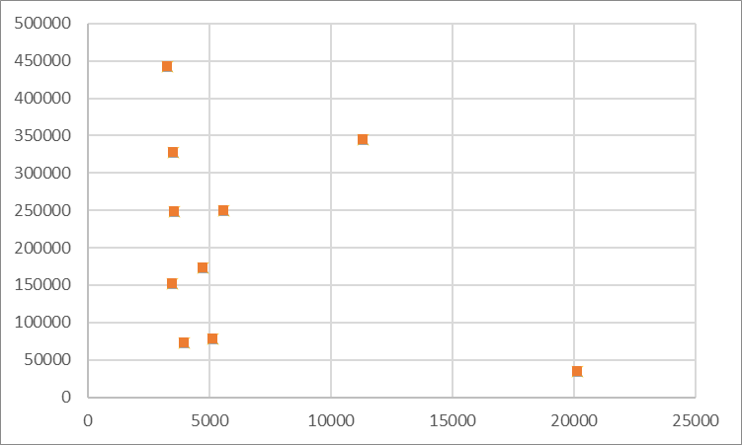

Graph X The scatter chart between price and sales data of the New energy automobile sales TOP10 in September 2020

Sources: https://car.autohome.com.cn/diandongche/index.html#pvareaid=3454690

We establish a linear regression model, $Y=β_{0}+β_{1}X+U$, where Y denotes the price, X denotes the sales volume, assuming E(U|X)=0. The estimator of the model is ${\hat{β}}_{1}=-8.6382$, ${\hat{β}}_{0}=268145$. Using the model obtained by linear regression, we calculate the price elasticity of new energy vehicle market, and the result is 0.22. It is learned that if the price elasticity of demand is less than 1, the good has inelastic demand. So the new energy vehicle has an inelastic demand, which is consistent with the statistic shown in the lecture note4.

The reasons why the new energy vehicle has an inelastic demand is multiple. The first reason is the selection of time horizon. Some commodities are inelastic in the short term but elastic in the long term. However, we only selected a cross-section data, so the elasticity is low. The second reason is defination of category. Generally speaking, the elasticity of commodity categories is lower than that of specific commodities. Here, we analyze the elasticity by taking commodity categories into account. The third is that we ignore some variable. These vehicle models are not completely replaced, which affects the calculation results. However, in a word, new energy vehicles are inelastic.

## Newspaper Article #3

### Article Title: The State Council: The new energy vehicle subsidy and tax exemption policy will be extended for two years

Article URL: https://www.guancha.cn/qiche/2020_03_31_544838.shtml

Microeconomics concept discussed: Government behavior; Externality

*Analysis:*

*One of the ten principles of Economics is that“Government can sometimes improve market outcomes.”Taking new energy vehicle for example,we’re trying to find out why and how government behavior is playing its role.*

*In order to promote automobile consumption, Executive Meeting of The State Council decided to extend the purchase subsidy and purchase tax exemption policy for new energy vehicles for two years. Second, the central government will support key areas such as The Beijing-Tianjin-Hebei region in phasing out diesel trucks with national emission standards of no. 3 or below. Third, sales of used cars to second-hand car dealers, from May 1 solstice at the end of 2023 sales at 0.5% VAT.*

*As we know,new energy vehicle is usually powered by natural gas, LPG, hydrogen and electricity so it saves fuel and energy.Additionally,new energy cars reduce exhaust emissions and effectively protect the environment. Electric cars produce no exhaust and no pollution. Hydrogen energy vehicle exhaust is water, no pollution to the environment. As it basically belongs to zero emission, it is also outside the limit range.*

*In a word,the increasing use of new energy vehicles has a positive effect on the bystander(stakeholders except the buyer and the seller).In economics,we call this “positive externalities”.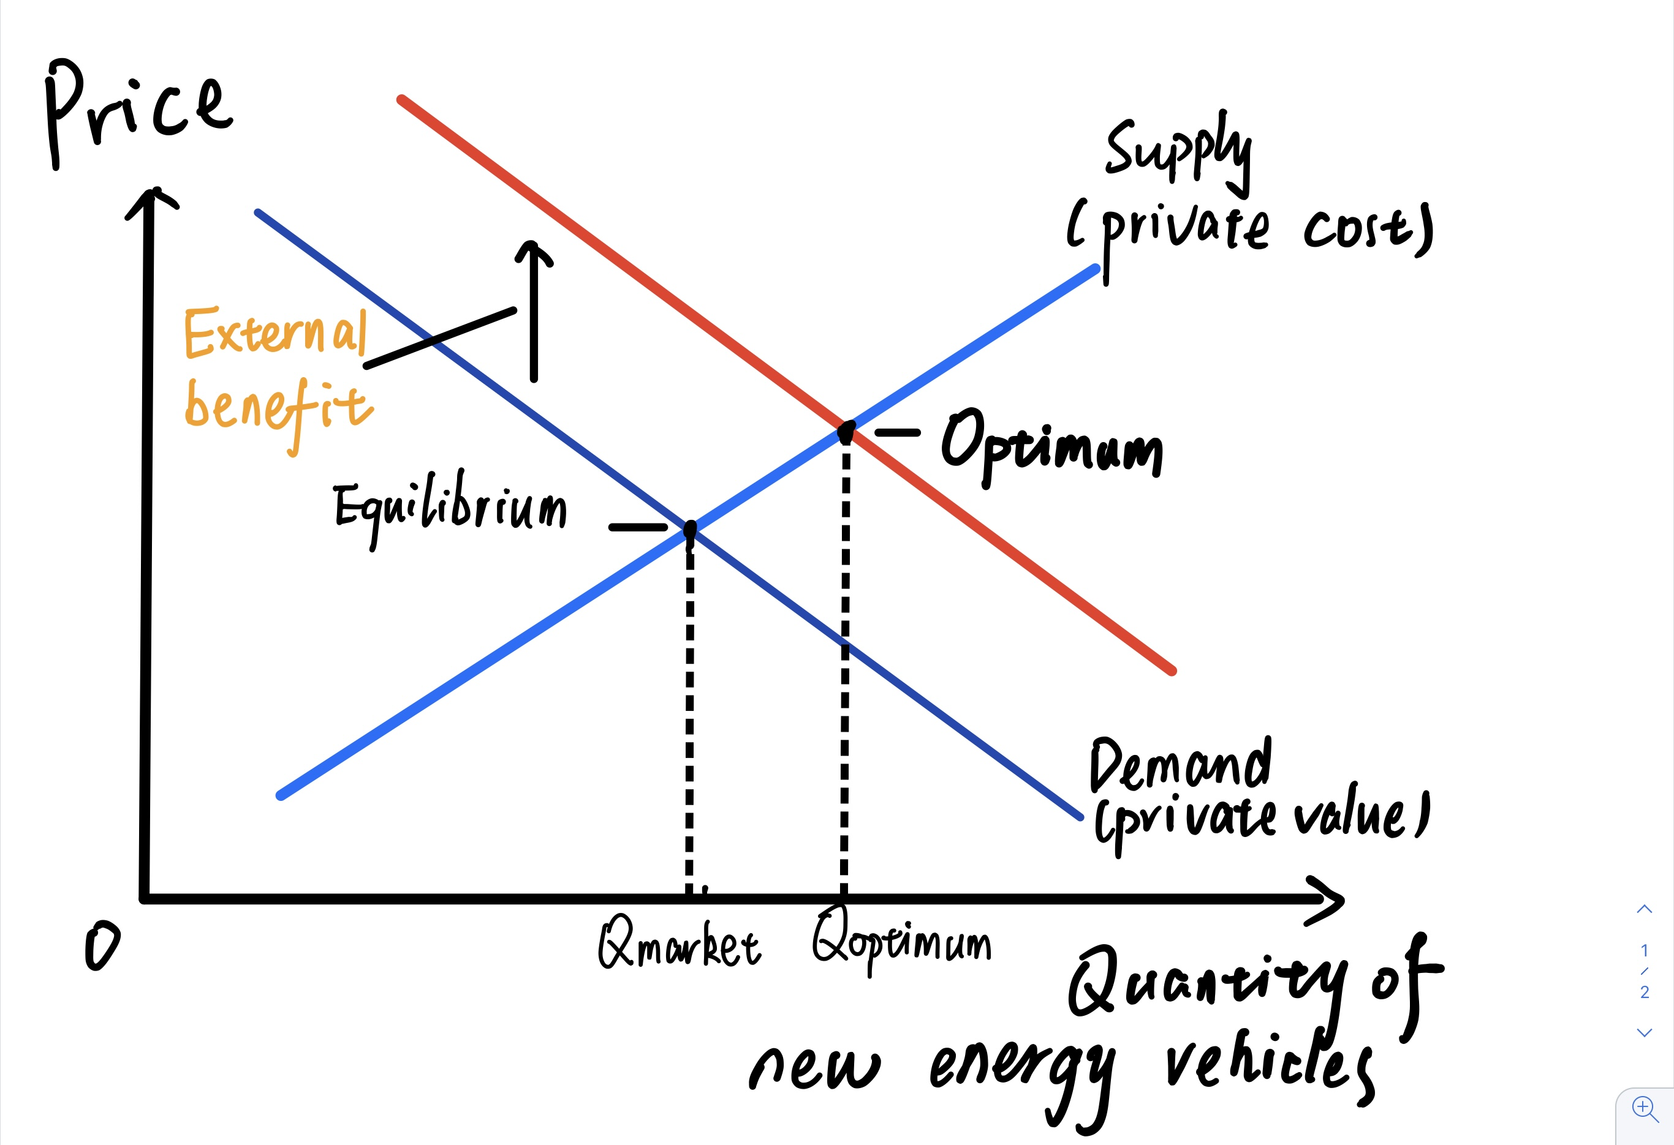*

*To get a more intuitive analysis of the impact,we draw graphs to illustrate it.As we know,demand curve of new energy vehicles only reflects private value but does not reflect the value to society.Because its social value is greater than the private value(saving fuels and energy,protect the environment,etc),the social-value curve lies above the demand curve.The optimal quantity is found where the social-value curve and the supply curve intersect.Hence,the socially optimal quantity of new energy vehicles is greater than the private market would naturally reach on its own,and this is why the government take action to promote the consumption of new energy vehicles.*

## Newspaper Article #4

### Article Title: People's daily people's review: seize the new opportunity of charging pile construction

Article URL: http://opinion.people.com.cn/n1/2020/0818/c1003-31825519.html

Microeconomics concept discussed: Consumer preferences

*Introduction:*

*China's new energy vehicle industry has made great progress and has become an important force leading the transformation and upgrading of the automobile industry.As an important accessory of new energy vehicles, the state is also strengthening charging piles’ construction.*

*Analysis:*

*Nowadays, the new energy vehicle industry is developing rapidly.Compared with traditional vehicles, new energy vehicles have many advantages.*

1. *Low driving cost.Generally speaking,the fuel consumption of a traditional car is 0.33 yuan per kilometer.Relatively,A new energy vehicle consumes about 0.1 yuan of electricity per kilometer.*
2. *More environmentally friendly.New energy vehicles are generally powered by electricity.Therefore, compared with traditional vehicles, new energy vehicles are more environmentally friendly and bring more positive externalities*
3. *Government subsidies.In order to promote the development of new energy vehicle industry and strengthen environmental protection.The government will increase subsidies for the purchase of new energy vehicles.*

*However,although new energy vehicles have many advantages, there are still many buyers who are not willing to buy new energy vehicles and choose to buy traditional vehicles. There are also many reasons. 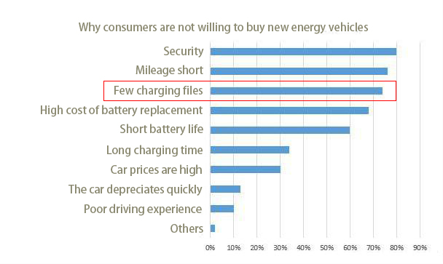*

*From the illustration we can see that "Few charging files” is a main reason why consumers are not willing to buy new energy vehicles.To solve this problem, the government and related enterprises have taken measures to strengthen the construction of charging pile.*

*Guoyuan securities estimates that under the target of vehicle to pile ratio of 1:1 in 2030, the increment of charging piles will exceed 50 million units, and the total investment in the charging pile market will reach nearly one trillion yuan in the next ten years.*

*Strengthening the construction of charging pile will improve the consumer's willingness to pay.*

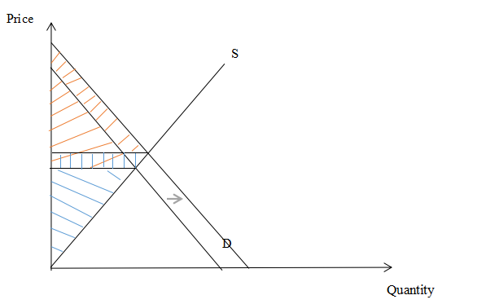

*When the consumer's willingness to pay increase, the demand curve also move, causing Consumer surplus and producer surplus increase.And finally it improves the efficiency of the market.*

## Newspaper Article #5

### Article Title: Analysis on the market competition pattern of China's new energy automobile industry in 2020 BYD ranked first （2020年中国新能源汽车行业市场竞争格局分析 比亚迪稳居第一）

### Article URL: https://new.qq.com/rain/a/20201221A046Q300

### Microeconomics concept discussed: perfect competition market

This article is an analysis of the market pattern of new energy vehicles. It deduces the current market structure through the calculation of a large number of data.

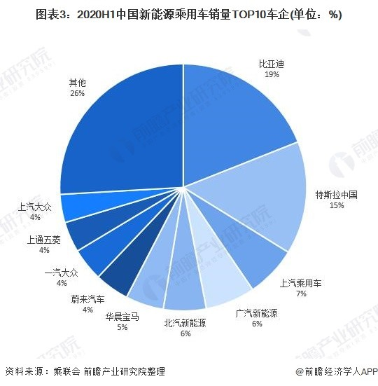

Graph X The market share of new energy passenger vehicle sales TOP10 enterprises in 2020H1

Source: https://new.qq.com/rain/a/20201221A046Q300

As can be intuitively seen from the above graph, China's new energy vehicle market is a competitive market at present. According to the provisions of the Anti-monopoly law, a firm with a market share of half, or two firms with a combined market share of two-thirds, or three firms with a combined market share of three-quarters may be defined as an operator with a dominant market position. However, as can be clearly seen from the above graph, no enterprise or joint enterprise can meet this standard. Therefore, the current new energy automobile market is not a monopoly, monopolistic competition, or oligopoly, but a truly perfect competitive market.

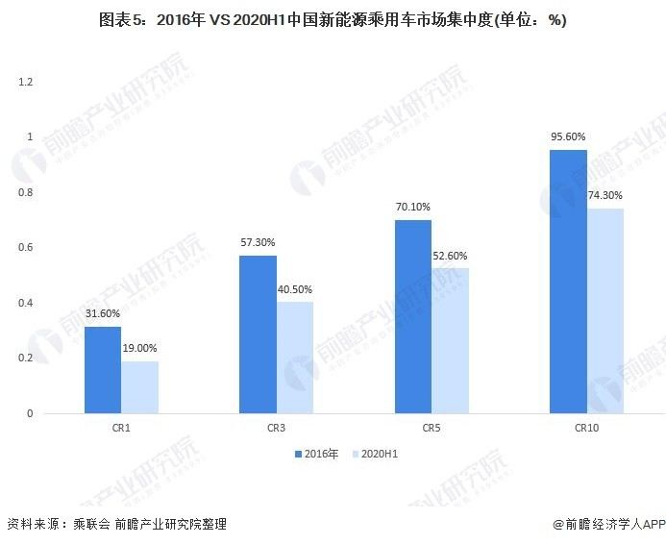

Graph X The market concentration of new energy passenger vehicle in 2016 and 2020

Source: https://new.qq.com/rain/a/20201221A046Q300

The chart shows the changes of market concentration in China's new energy automobile market in recent years. It can be clearly seen that the market concentration decreases, which means that the market competition becomes fiercer.

Reviewing the definition of a perfectly competitive market, we can confirm our conclusion. First, there are many firms in the market sell identical products, new energy vehicle, to numerous buyers. Second, both buyers and sellers are price takers, neither a firm or a purchaser can determine the price. Third, there are free entry and exit mechanisms to the industry. In summary, the market of new energy is perfect competitive.

## Conclusion

This report selected one of the most popular industries at present, the new energy automobile industry, and combined with the economic knowledge to analyze. This report can be divided into five parts. In the first report, we chose the concepts of supply and demand and analyzed the reasons why the new energy automobile industry will grow against the trend in 2020 under the impact of the epidemic. In the second report, we chose elasticity as our tool and drew the conclusion that the demand for new energy vehicles is inelastic. In the third report, we choose the concept of consumer preference. We find that charging pile problem is the main reason why consumers are unwilling to buy new energy vehicles, and strengthening the construction of charging pile will help to improve consumers' willingness to pay. In the fourth report, we focus on the reasons and ways for the government's actions to play a role. We find that the government is using economic means to promote the sales of new energy vehicles, so as to expand their positive externalities and achieve the optimal number of vehicles in society. In the fifth report, we examined the market share of new energy vehicles and drew the conclusion that new energy vehicles are now a perfectly competitive market. Overall, the report takes a sharp look at the new energy vehicle market with an economist's eye.

## References:

Anti-monopoly Law of the People's Republic of China. 2007. Retrieved from http://search.chinalaw.gov.cn/law/searchTitleDetail?LawID=332854&Query=%E5%8F%8D%E5%9E%84%E6%96%AD%E6%B3%95&IsExact=&PageIndex=2

Analysis on the market competition pattern of China's new energy automobile industry in 2020 BYD ranked first Retrieved from https://new.qq.com/rain/a/20201221A046Q300

The best seller was not Tesla's TOP5 new energy vehicle sales in September. Retrieved from https://www.chexiaoliang.com/nengyuan/1817.html

The sales data and prices of the new energy automobile sales TOP10 in September 2020. Retrieved fromhttps://car.autohome.com.cn/diandongche/index.html#pvareaid=3454690

Executive Meeting of The State Council’s decision.Retrieved from

https://www.guancha.cn/qiche/2020_03_31_544838.shtml

Shenzhen new energy vehicle consumption survey results show that safety is the most important concern for consumers. Retrieved from <https://www.thepaper.cn/newsDetail_forward_10400942>

Tesla's Shanghai hypercharge factory will be put into operation soon, and all kinds of capital will dig up trillions of dollars in the market.Retrieved from https://www.thepaper.cn/newsDetail_forward_10531989

---- END OF REPORT ----